1.
import java.util.Scanner;

public class LibraryManagement extends LibOperations implements UserDetails {
public static void main(String[] args) {
int opt;
char a;
LibraryManagement lib = new LibraryManagement();
Scanner sc = new Scanner(System.in);
do {
System.out.println("Choose an option: /n1.User Details/n2.Login/n3.Issue book/n4.Return Book/n5.exit");
System.out.println("Enter your option: ");
opt = sc.nextInt();
switch (opt) {
case 1:
lib.getDetails();
break;
case 2:
lib.login("Shobhit@29", "abcde");
break;
case 3:
lib.issueBook(101);
break;
case 4:
lib.retBook(101);
break;
case 5:
System.exit(0);
default:
System.out.println("Wrong input");
break;
}
System.out.println("Do you want to continue? y/n");
a = sc.next().charAt(0);
}
while (a == 'y');
}

LibraryManagement() {

}

public void getDetails() {
System.out.println("Name :" + name);
System.out.println("Age: " + age);
}

public void login(String user, String pass) {
if (user == "Shobhit@29" && pass == "abcde") {
System.out.println("Access Granted!");
} else
System.out.println("Access Denied");
}

public void issueBook(int bookId) {
System.out.println(bookId + " issued to " + username);
}

public void retBook(int bookId) {
System.out.println(bookId + " returned by " + username);
}
}

2.
public class StringSort {
public static void main(String[] args) {
String s = "Javaisgood";
char str[] = s.toCharArray();
char temp;
for (int i = 0; i < str.length; i++) {
for (int j = i + 1; j < str.length; j++) {
if (str[i] > str[j]) {
temp = str[i];
str[i] = str[j];
str[j] = temp;
}
}
}
System.out.println("Sorted string");
for (int i = 0; i < str.length; i++) {
System.out.println(str[i]);
}
}
}

3.
a.
public class ExceptionExample {
public static void main(String[] args) {
ExceptionExample e = new ExceptionExample();
Class.forName("First");
}
}Create a custom exception that do not have any

b.
public class ExceptionExample {
public void print(){
System.out.println("Hello");
}
}
class First{
public static void main(String[] args) {
ExceptionExample e = new ExceptionExample();
e.print();
}
}

*Remove ExceptionExample.class file after compiling and running, then run again

4.
class Singleton
{
private static Singleton single_instance = null;
public String s;
private Singleton()
{
s = "Hello I am a string part of Singleton class";
}
public static Singleton getInstance()
{
if (single_instance == null)
single_instance = new Singleton();

return single_instance;
}
}
class Main {
public static void main(String args[]) {
Singleton x = Singleton.getInstance();
Singleton y = Singleton.getInstance();
Singleton z = Singleton.getInstance();
}
}

5.
a)

public class CloneEx implements Cloneable {

private String name;

public CloneEx(String name) {
this.name = name;
}

public String getName() {
return name;
}

public Object clone()throws CloneNotSupportedException{
return super.clone();
}

public static void main(String[] args) {
CloneEx c = new CloneEx("A");
try {
CloneEx c2 = (CloneEx) c.clone();
System.out.println(c2.getName());
} catch (CloneNotSupportedException e) {
e.printStackTrace();
}
}
}

b)

public class CloneEx implements Cloneable {
int id;
String name;
String city;
public CloneEx(){}
public CloneEx(CloneEx original) {
this.id = original.id + 1;
this.name = new String(original.name);
this.city = new String(original.city);
}
public static void main(String[] args) {
CloneEx ce = new CloneEx();
ce.id = 101;
ce.name = "s";
ce.city = "delhi";
CloneEx ce2 = new CloneEx(ce);
System.out.println(ce2.name+" "+ce2.id+" "+ce2.city);
}
}
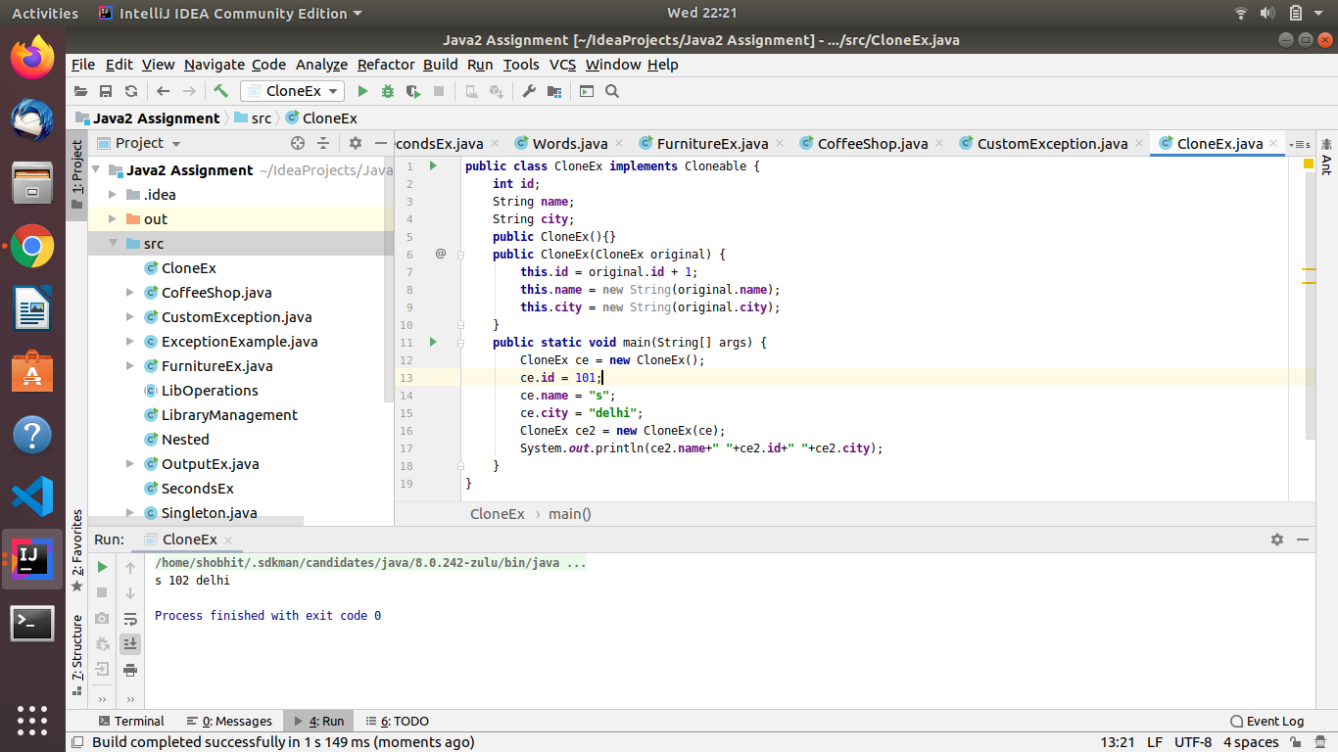

6.
public class TryCatchEx {
public static void main(String[] args) {
try {
int a = 10;
int b = 0;
int c;
int arr[] = new int[5];
c = a / b;
System.out.println(arr[10]);
}
catch(ArithmeticException a){
a.printStackTrace();
}
catch(Exception e){
e.printStackTrace();
}
finally {
System.out.println("All errors caught");
}
}
}
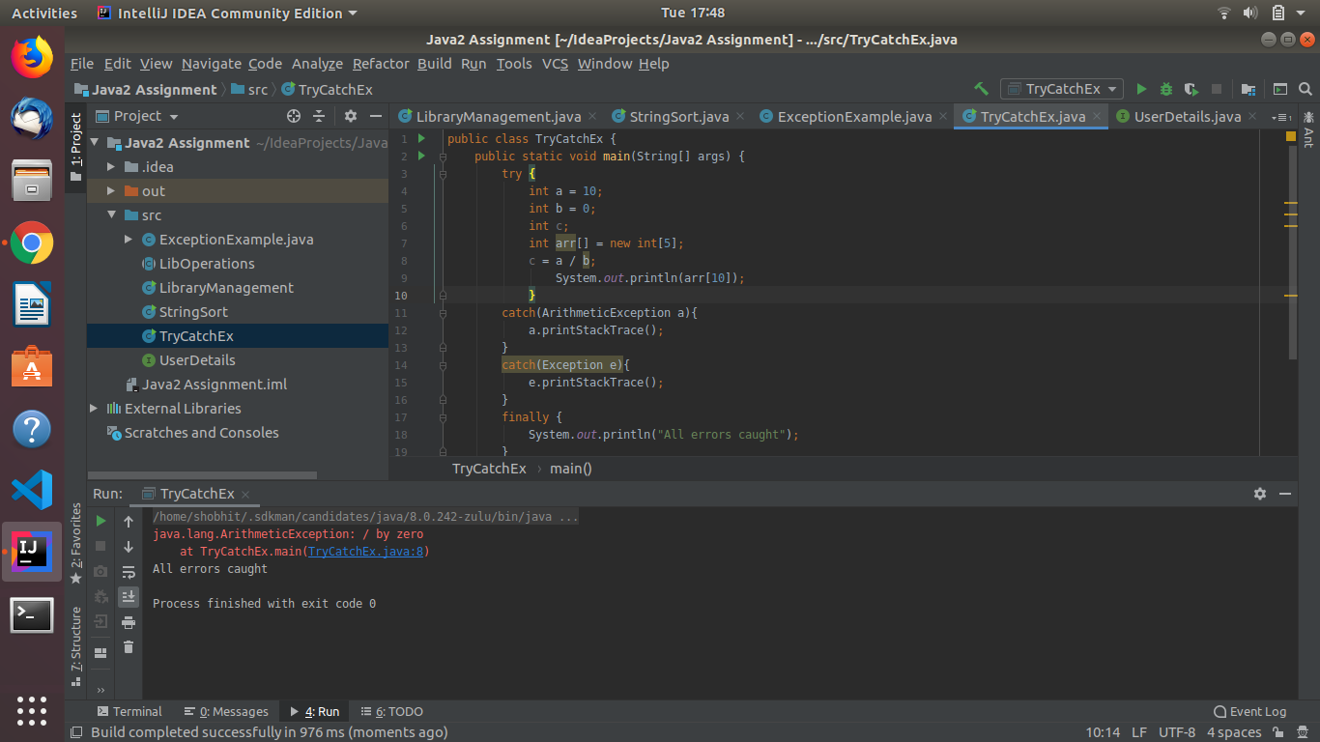

7.
public class SecondsEx {
public static void main(String[] args) {
SecondsEx se = new SecondsEx();
int sec = 216854;
se.ConvertSectoDay(sec);
}
public void ConvertSectoDay(int n)
{
int day = n / (24 * 3600);

n = n % (24 * 3600);
int hour = n / 3600;

n %= 3600;
int minutes = n / 60 ;

n %= 60;
int seconds = n;

System.out.println( day + " " + "days " + hour
+ " " + "hours " + minutes + " "
+ "minutes " + seconds + " "
+ "seconds ");
}
}
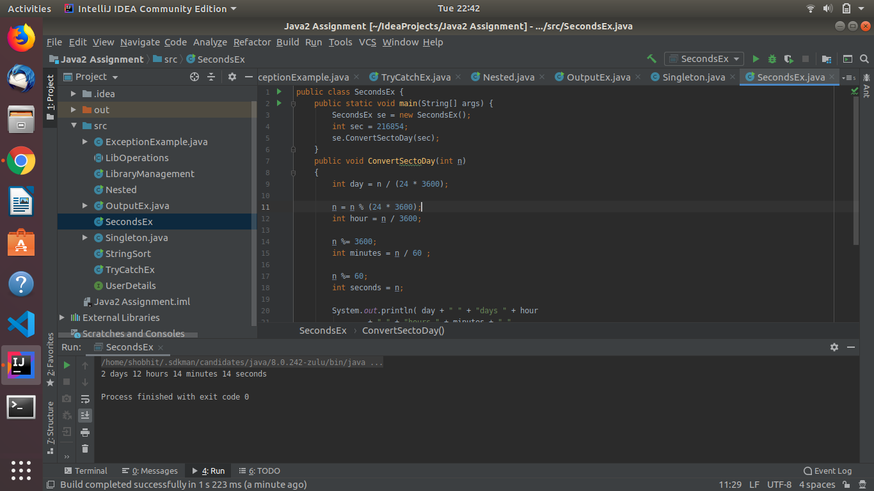

8.
a. while

import java.util.Scanner;

public class Words {
public static void main(String[] args) {
Words w = new Words();
w.check();
}
public void check(){
String str;
Scanner sc = new Scanner(System.in);
System.out.println("Enter a word");
str = sc.next();
while(!str.equals("done")){
if(str.charAt(0)==str.charAt((str.length()-1)))
System.out.println("First and last character of the word are same");
else
System.out.println("First and last chracter of the word are not same");
System.out.println("Enter a word");
str = sc.next();
}
if (str.equals("done"))
System.out.println("Bye");
}
}
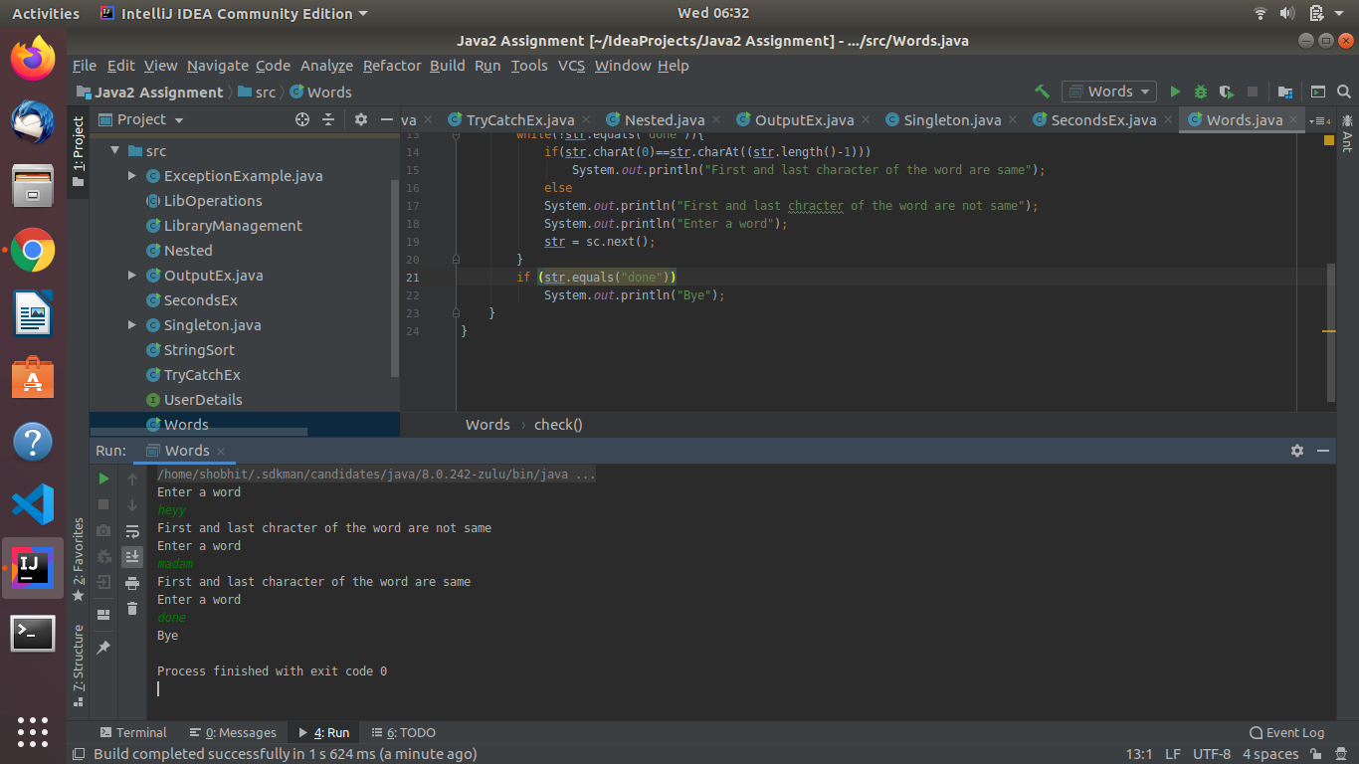

b. do-while

import java.util.Scanner;

public class Words {
public static void main(String[] args) {
Words w = new Words();
w.check();
}

public void check() {
String str;
Scanner sc = new Scanner(System.in);
System.out.println("Enter a word");
str = sc.next();
do {
if (str.equals("done"))
break;
if (str.charAt(0) == str.charAt((str.length() - 1)))
System.out.println("First and last character of the word are same");
else
System.out.println("First and last chracter of the word are not same");
System.out.println("Enter a word");
str = sc.next();
} while (!str.equals("done"));
if (str.equals("done"))
System.out.println("Bye");
}
}

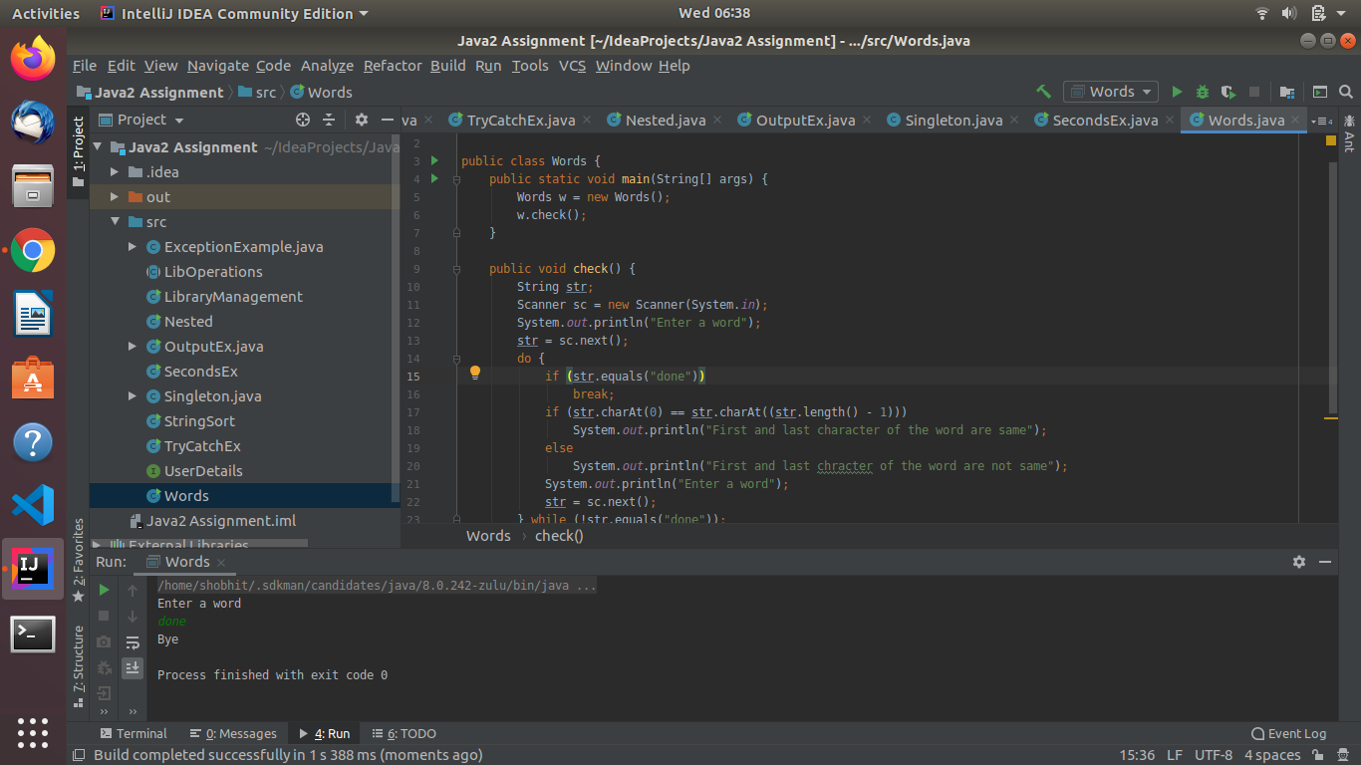

9.
import java.util.Scanner;

interface Furniture {
public void stressTest();

public void fireTest();
}

abstract class Chair implements Furniture {
public abstract String chairType();

}

abstract class Table implements Furniture {
public abstract String tableType();
}

class MetalChair extends Chair {
@Override
public void stressTest() {
System.out.println("Passed stress test");
}

@Override
public void fireTest() {
System.out.println("Passed fire test");
}

@Override
public String chairType() {
String str = "This is metal chair";
return str;
}
}

class MetalTable extends Table {
@Override
public void stressTest() {

System.out.println("Passed Stress Test");
}

@Override
public void fireTest() {
System.out.println("Passed Fire Test");
}

@Override
public String tableType() {
String str = "This is a metal Table";
return str;
}
}
class WoodenTable extends Table {
@Override
public void stressTest() {
System.out.println("Failed Stress Test");
}

@Override
public void fireTest() {
System.out.println("Failed Fire Test");
}

@Override
public String tableType() {
String str = "This is a wooden Table";
return str;
}
}

class WoodenChair extends Chair {
@Override
public void stressTest() {
System.out.println("Failed stress test");
}

@Override
public void fireTest() {
System.out.println("Failed fire test");
}

@Override
public String chairType() {
String s = "This is wooden chair";
return s;
}
}

public class FurnitureEx {
public static void main(String[] args) {
Table t = null;
Chair c = null;
char opt;
Scanner sc = new Scanner(System.in);
do {
System.out.println("Choose an option:/na)Wooden chair/nb)Metal chair/nc)Wooden table/nd)Metal table/ne)exit/n");
System.out.println("Enter your option:");
opt = sc.next().charAt(0);
switch (opt){
case 'a':
c = new WoodenChair();
System.out.println(c.chairType());
c.stressTest();
c.fireTest();
break;
case 'b':
c = new MetalChair();
System.out.println(c.chairType());
c.stressTest();
c.fireTest();
break;
case 'c':
t = new WoodenTable();
System.out.println(t.tableType());
t.stressTest();
t.fireTest();
break;
case 'd':
t = new MetalTable();
System.out.println(t.tableType());
t.stressTest();
t.fireTest();
break;
case 'e':
System.exit(0);
break;
default:
System.out.println("Wrong choice!");
}
System.out.println("Do you want to continue? y/n");
opt = sc.next().charAt(0);
}while(opt=='y');
}
}
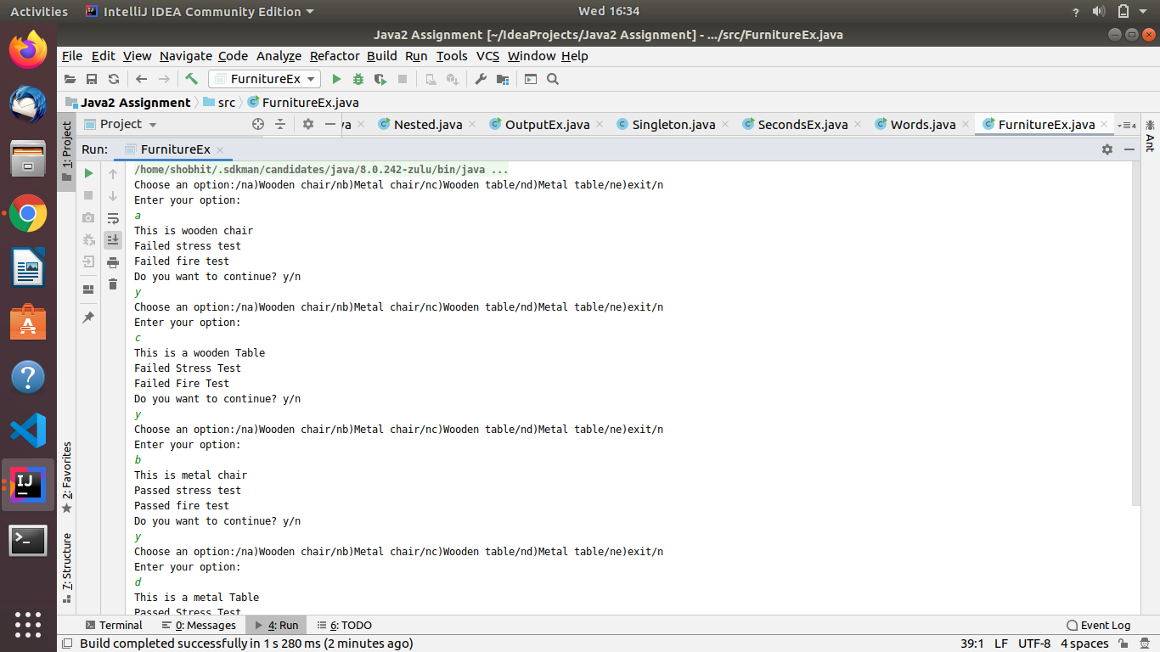

10.
public class CoffeeShop {
public static void main(String[] args) {

}
}
class Customer{
static int tokenNum;
int i = 0;
int placeOrder(double cash){
return tokenNum;
}
int waitForOrder(int time){
return time;
}
}
class Cashier{
void getOrder(double cash){}
void createOrder(int arr[]){}
}
class Barista{
void checkOrder(int arr[]){}
int[] readyOrder(int arr[]){
return arr;
}
void notification(){}
}

11.
public class Nested {
public static void main(String[] args) {
int s = 0;
int t = 1;
int i= 0;
while(i<10)
{
s = s + i;
int j = i;
while(j>0)
{
t = t * (j - i);
j--;
}
s = s * t;
System.out.println("T is " + t);
i++;
}
System.out.println("S is " + s);
}
}
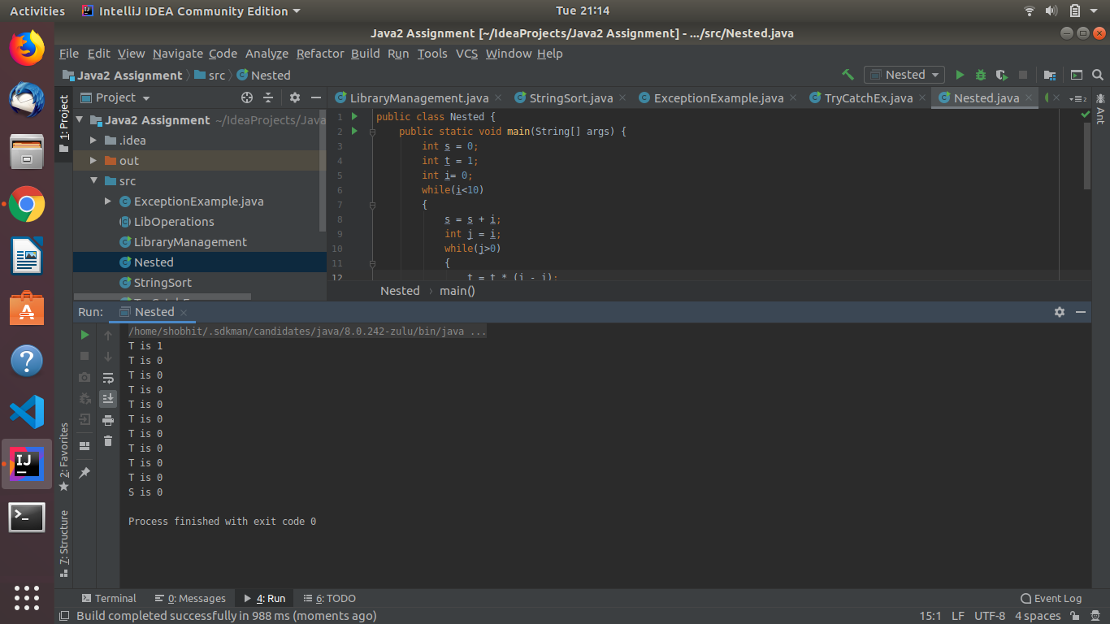

12.
class Parent extends Grandparent {

{
System.out.println("instance - parent");
}

public Parent() {
System.out.println("constructor - parent");
}

static {
System.out.println("static - parent");
}
}

class Grandparent {

static {
System.out.println("static - grandparent");
}

{
System.out.println("instance - grandparent");
}
public Grandparent() {
System.out.println("constructor - grandparent");
}
}

class Child extends Parent {

public Child() {
System.out.println("constructor - child");
}

static {
System.out.println("static - child");
}
{
System.out.println("instance - child");
}
}
public class OutputEx {
public static void main(String[] args) {
Child ch = new Child();
}
}
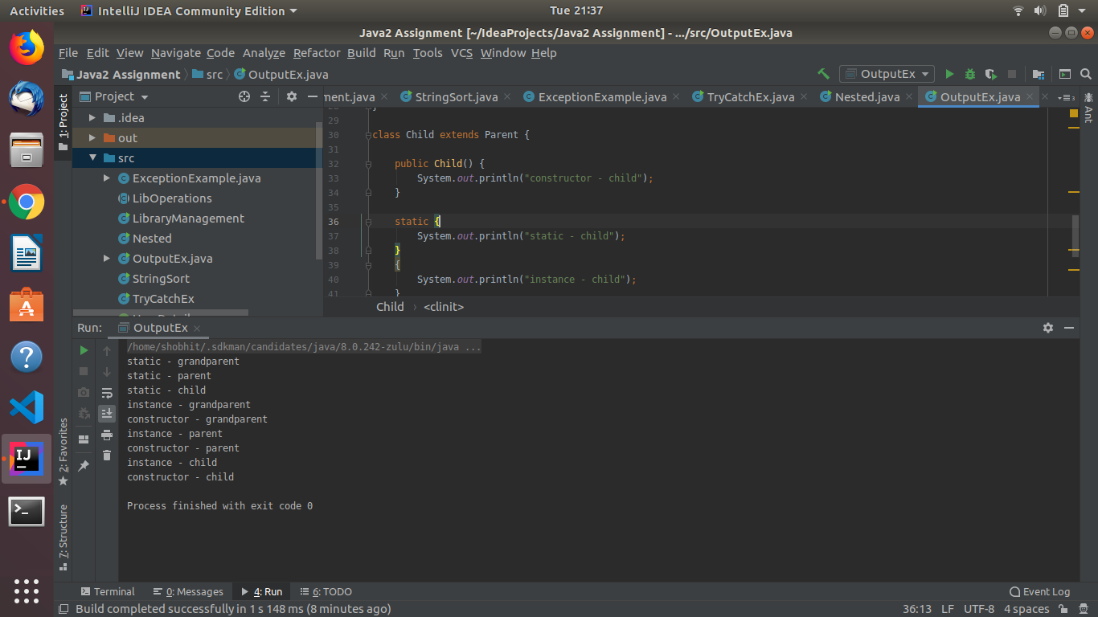

13.
import java.util.concurrent.Executors;
public class CustomException {
public static void main(String[] args) throws CustomaryException {
int i=0;
if(i==0){
throw new CustomaryException("Anything but zero");
}
}
}
class CustomaryException extends Exception{
public CustomaryException(String s){
super(s);
}
@Override
public synchronized Throwable fillInStackTrace() {
return this;
}
}